
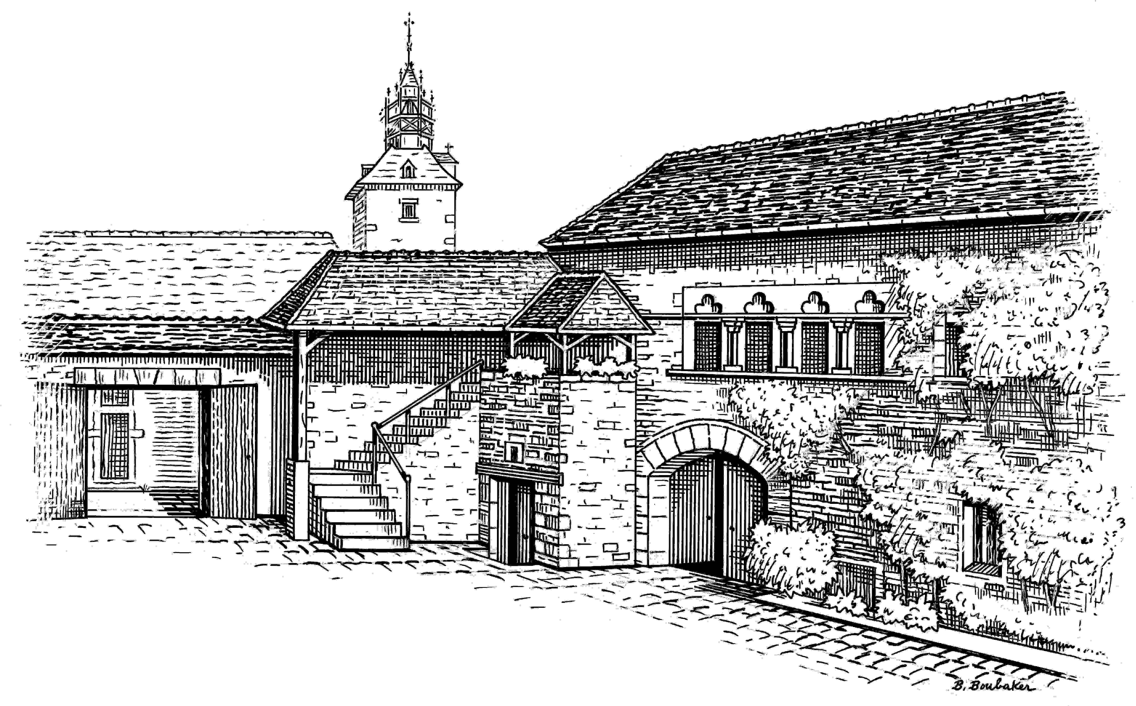
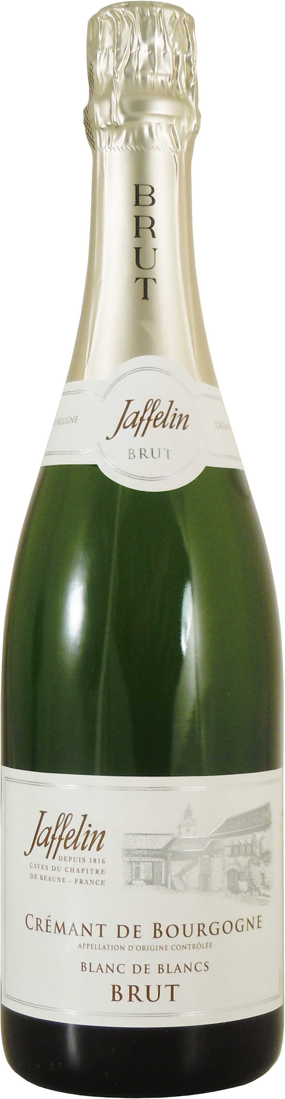
Crémant de Bourgogne Brut Blanc de Blancs

DESCRIPTIVE & VINIFICATION

Grape variety: Chardonnay, Aligoté.
Vinification: This Blanc de Blancs Crémant de Bourgogne is elaborated only from white grapes, and mainly Chardonnay.
Made in the traditional way, the second fermentation takes place in the bottle to obtain more delicate and fine bubbles.
Descriptive: This wine is an intermingling of grapes from different areas, each for their own very special characteristics. Those from the Mâconnais give fattiness and suppleness, while those from the Yonne and the Châtillonnais give liveliness and freshness.

TASTING NOTES

Colour: When young it is quite pale, taking on golden or straw-colored tints with the years.

Nose: Very pleasant with citrus and flower notes, evolving to buttery and brioche notes with age.

Mouth: Very fresh and lively.

ALLIANCE
Aperitif, seafood, fish and white meats,
crème brûlée, foie gras.

SERVICE TEMPERATURE
6°C / 8°C

AGEING POTENTIAL
Between 2 to 3 years

2 Rue Paradis – 21200 BEAUNE – Côte d’Or - France
Tél : 03 80 22 12 49 – Fax : 03 80 24 91 87 - Email : jaffelin@maisonjaffelin.com

