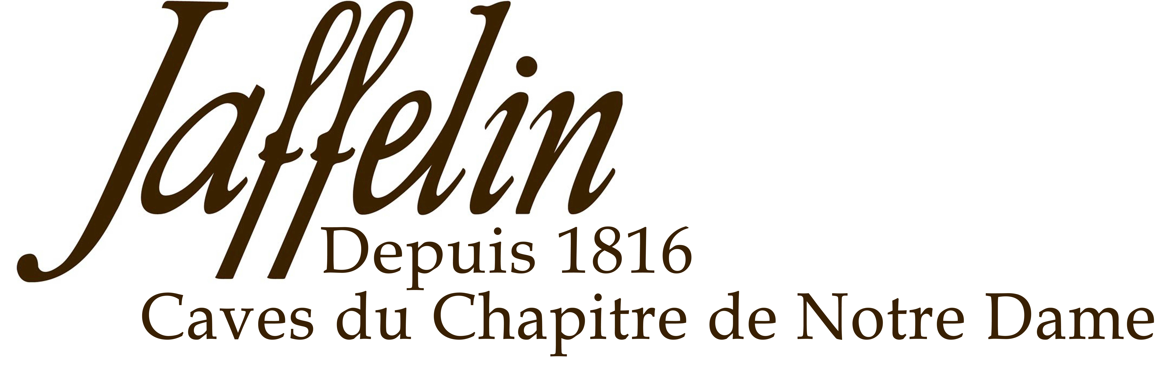
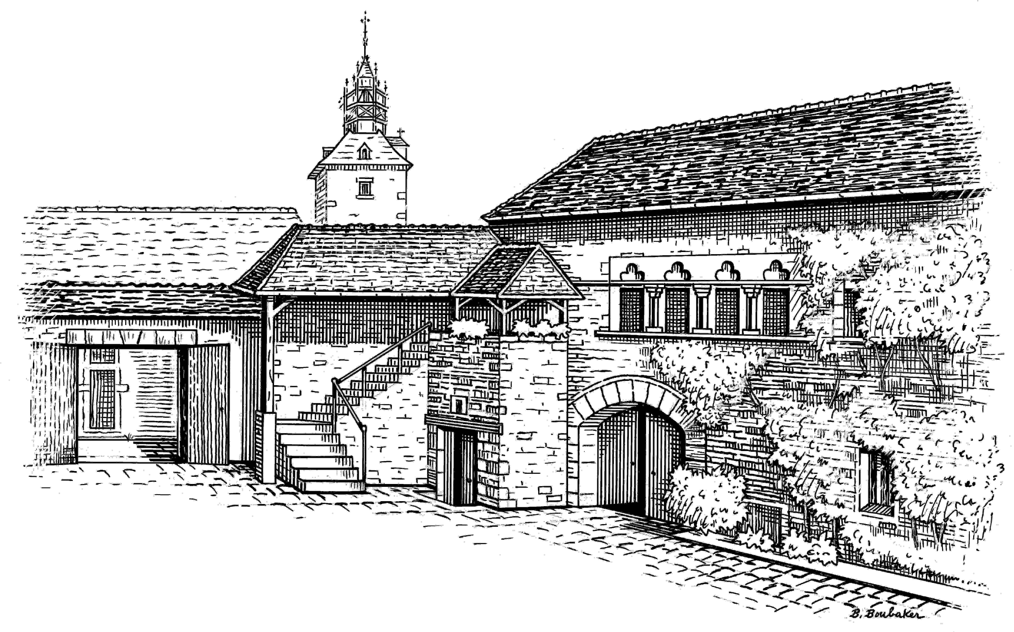
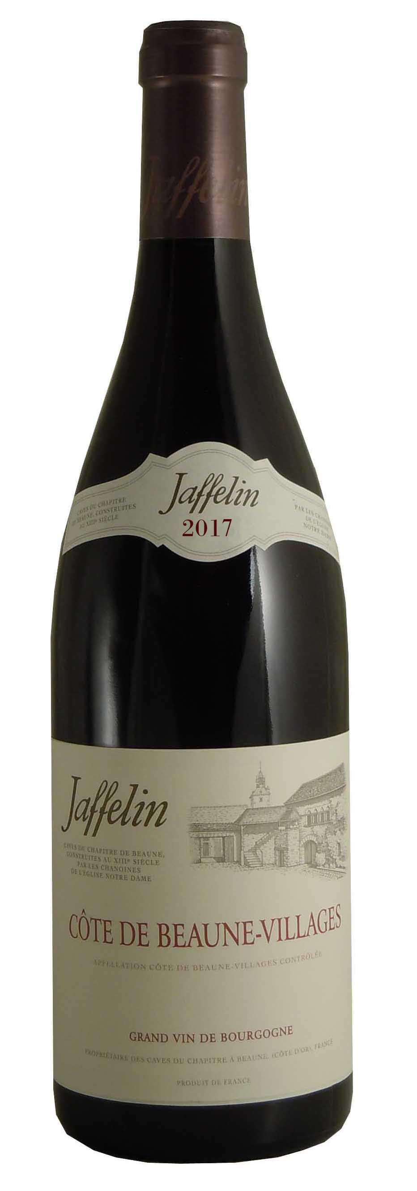
DESCRIPTIVE

Grape Variety: Pinot Noir
Burgundy’s wine-capital, Beaune, lends its name to 5,000 hectares of majestic vineyards which extend from the villages of Ladoix-Serrigny to the hill-slopes of the Maranges.
Variations in terroir hereabouts make the wines of the Côte de Beaune as diverse in character as they are high in quality, with full, harmonious, thoroughbred red wines.

2017 is a hot vintage in Burgundy which laid the foundations for a very early harvest; from the last days of August in the Mâconnais and in some areas of the Côte de Beaune and the Côte Chalonnaise. Five consecutive months before the harvest of very favorable weather conditions have generally been the sign in the past of one of these great vintages for aging, where there is great qualitative homogeneity in everyone.

TASTING NOTES

Colour: The robe is a limpid, brilliant red colour.
Nose: The nose is elegant with aromas of red ripe fruits.
Mouth: Balanced tannins with oaky and fruity notes

ALLIANCE
Marinated meat, duck breast, all kind of cheese…

SERVICE TEMPERATURE
15°C / 16°C

AGEING POTENTIAL
4 to 5 years

2 Rue Paradis – 21200 BEAUNE – Côte d’Or - France
Tél : 03 80 22 12 49 – Fax : 03 80 24 91 87 - Email : jaffelin@maisonjaffelin.com

Côte de Beaune Villages 2017

