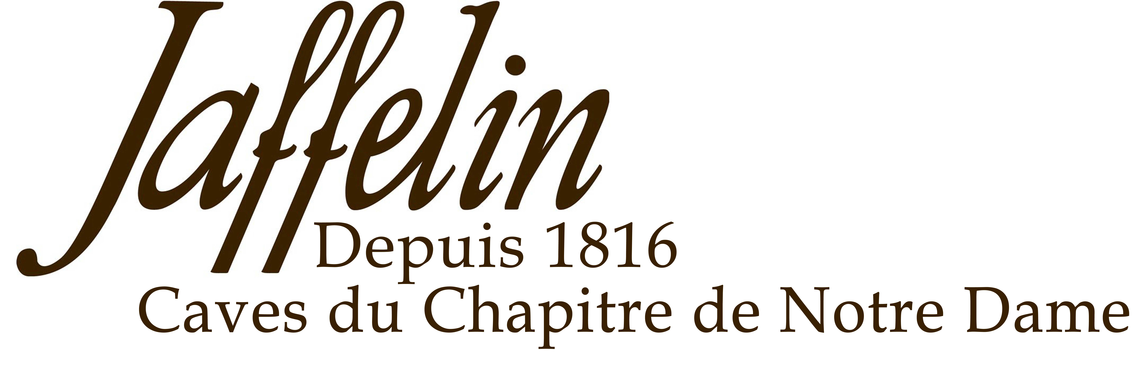
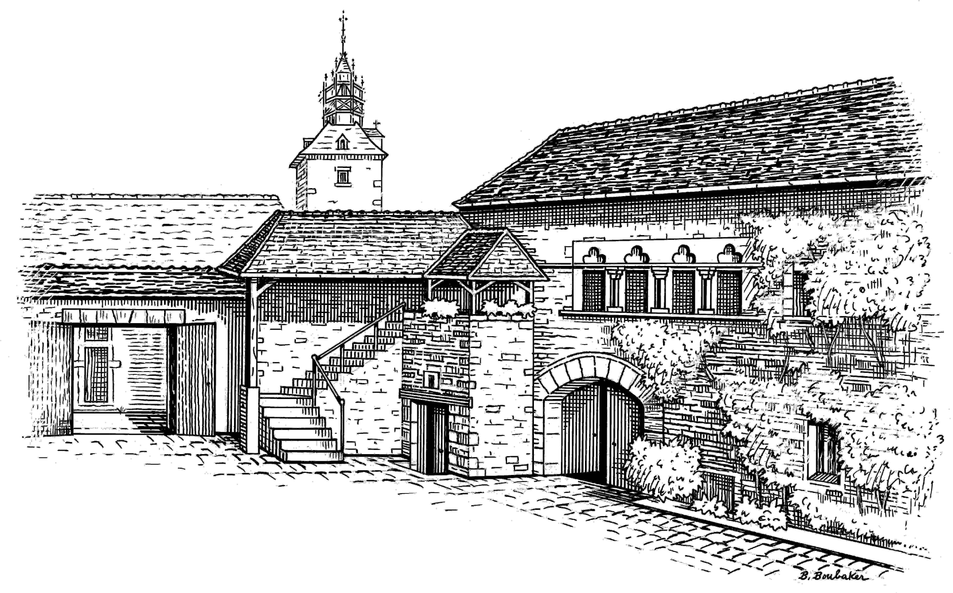
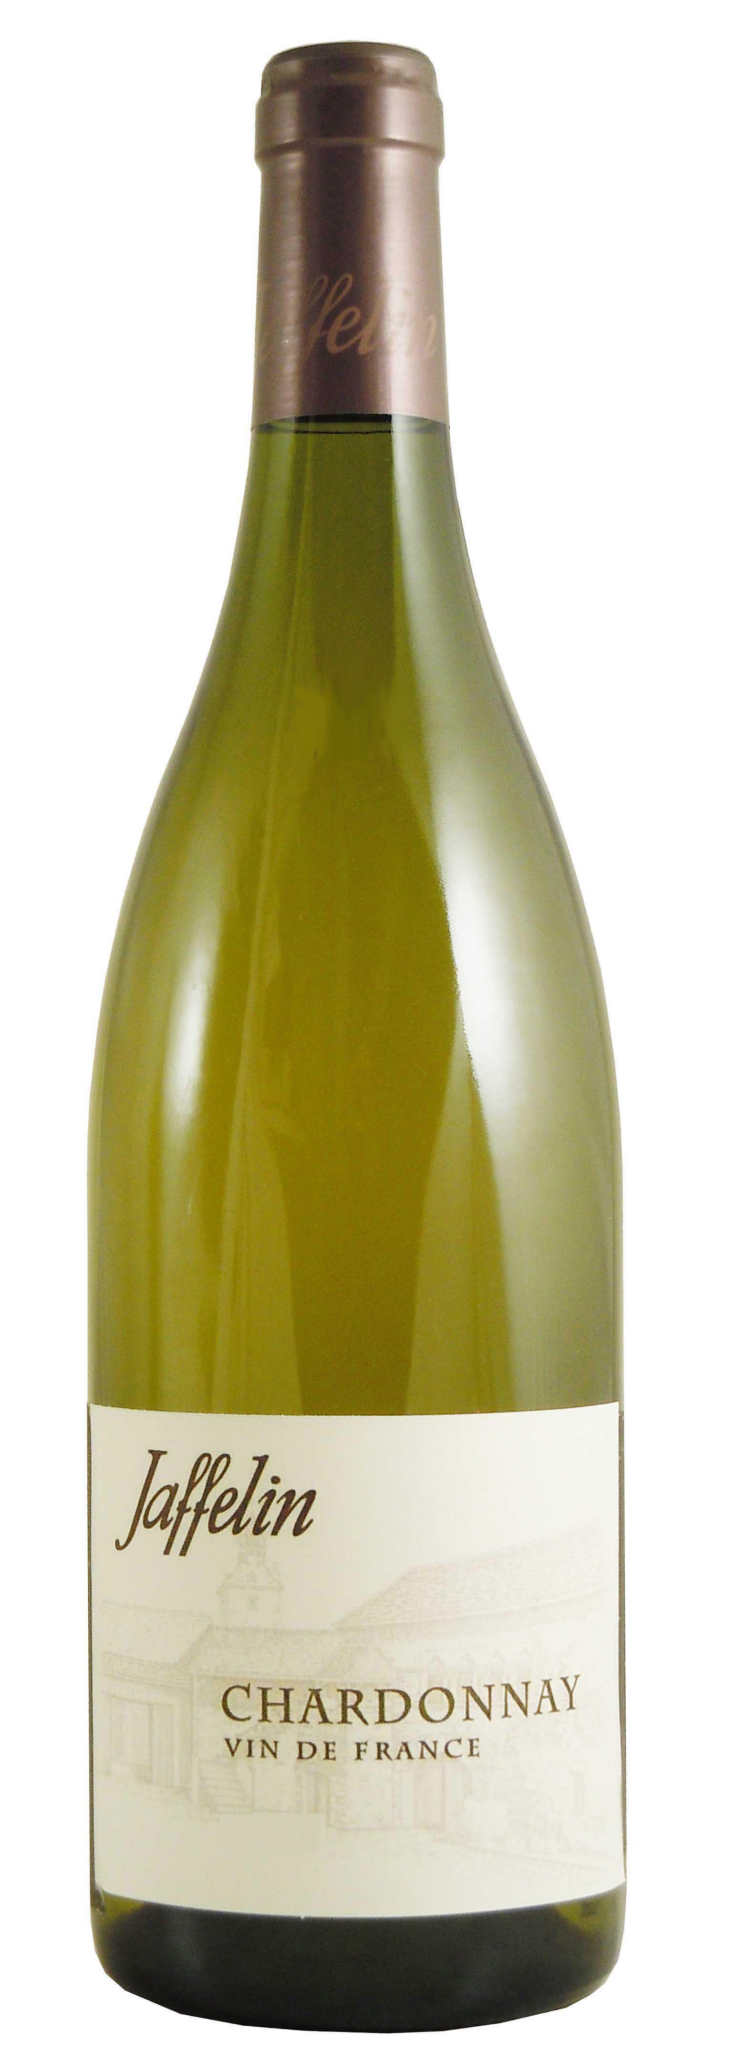
Chardonnay
Vin de France

DESCRIPTIVE & VINIFICATION

Cépage : Chardonnay

Vinification : Chardonnay, the best known variety in the world. It is the only variety used in the best dry white wines in this region. The grapes come from the South of France and Burgundy.
The alcoholic and malo-lactic fermentation takes place in steel tanks to preserve the freshness.

TASTING NOTES

Color : Golden yellow colour with a beautiful brilliance.
Nose : The bouquet is clean and offers floral aromas followed with green apple and nectarine notes.
Mouth : This wine is dry and very fresh. Good balance between fruit, acidity and roundness. Long and pleasant finish.

ALLIANCE
Ham, all kinds of cold meats, grilled fishes, poultry in creamy sauces, fresh goat cheeses, sushis...

SERVICE TEMPERATURE
10°C / 12°C

AGEING POTENTIAL
Ready to drink now but may last 4 years.

2 Rue Paradis – 21200 BEAUNE – Côte d’Or - France
Tél : 03 80 22 12 49 – Fax : 03 80 24 91 87 - Email : jaffelin@maisonjaffelin.com

