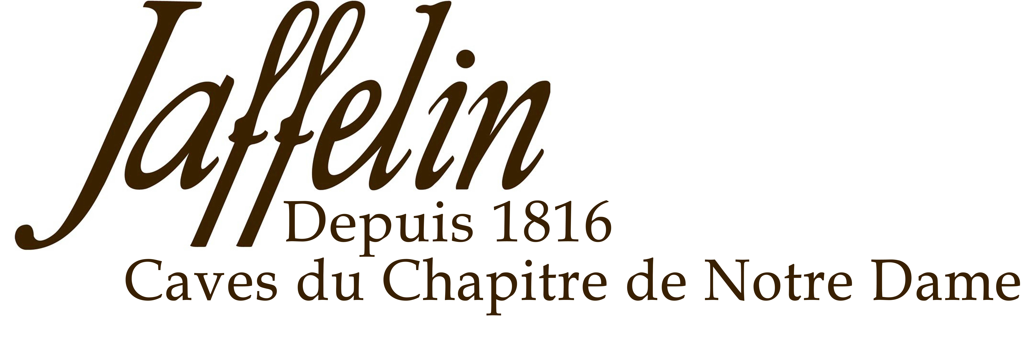
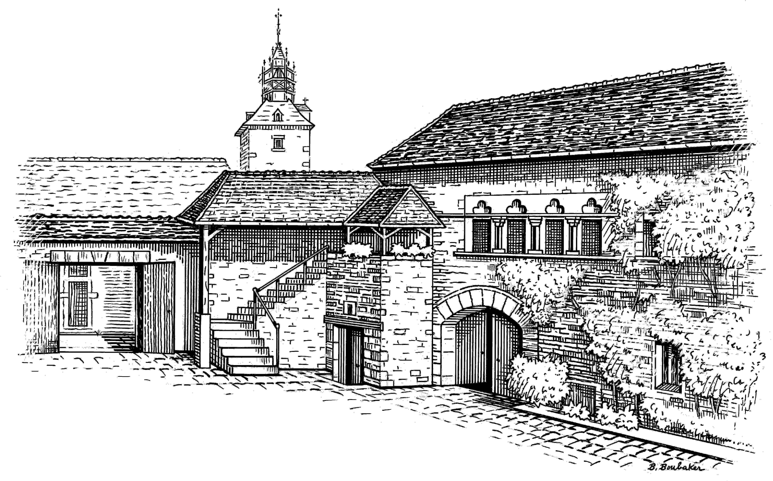
DESCRIPTIVE & VINIFICATION

Cépage : Pinot Noir
Vinification : Maison Jaffelin has exclusively selected Pinot Noir grapes to elaborate this excellent Vin de France Pinot Noir.
The influence of southern climate brings to this wine ripe and jammy nuances of dark colour fruits such as blackcurrant, blackberry, blackcherry, etc. The charming flavour has sufficiently evolved, and this wine is now ready to drink.

TASTING NOTES

Colour : This wine has a beautiful red purple colour. It is limpid and brilliant.
Nose : The bouquet is round and explosive with aromas of cherry and small red fruits.
Mouth : The attack is soft. It is complex and rich, with presence of fine quality tannins and with a great length.

ALLIANCE
Sausage with cream sauce, game, beef stew, duck, cheeses…..

SERVICE TEMPERATURE
10°C / 12°C

AGEING POTENTIAL
To be drunk young and fresh.

2 Rue Paradis – 21200 BEAUNE – Côte d’Or - France
Tél : 03 80 22 12 49 – Fax : 03 80 24 91 87 - Email : jaffelin@maisonjaffelin.com

Pinot Noir
Vin de France

