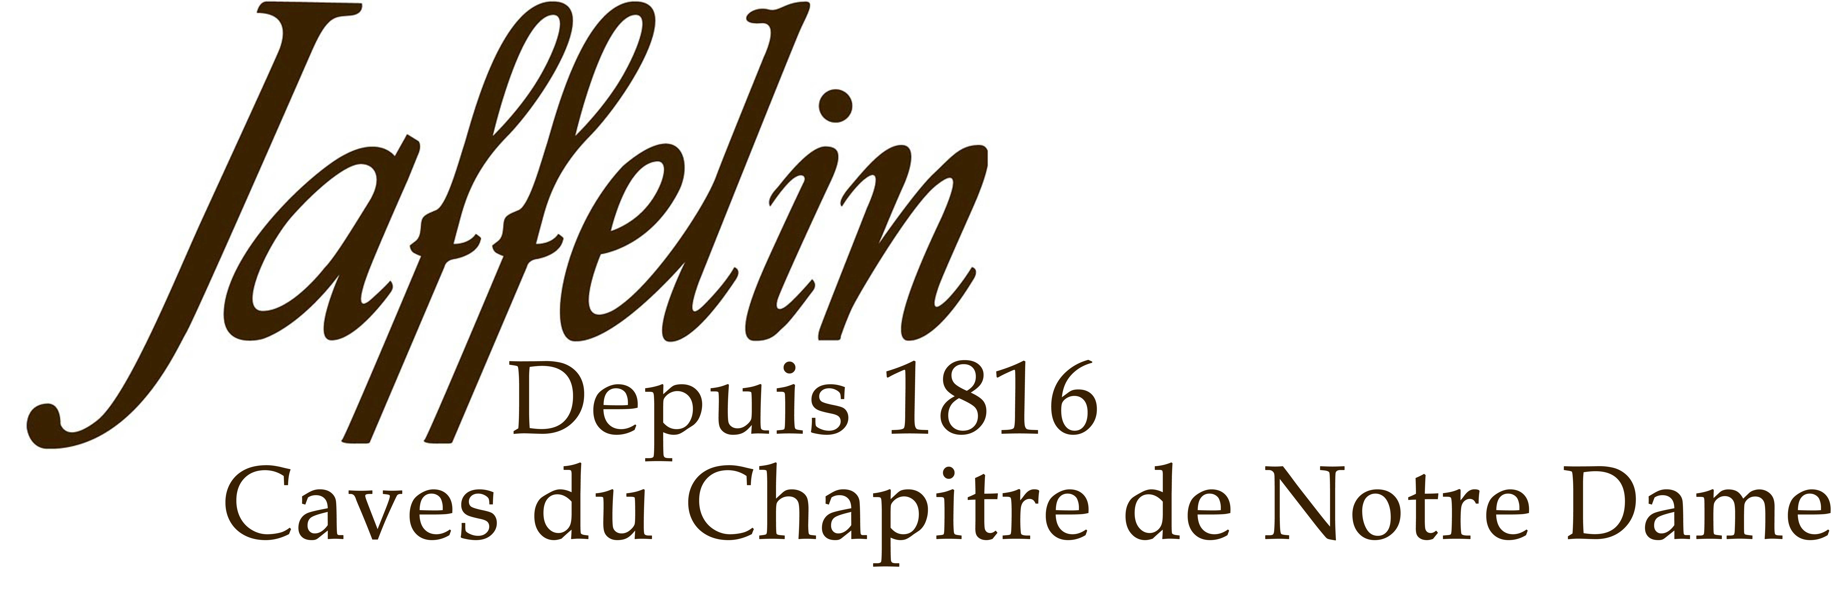
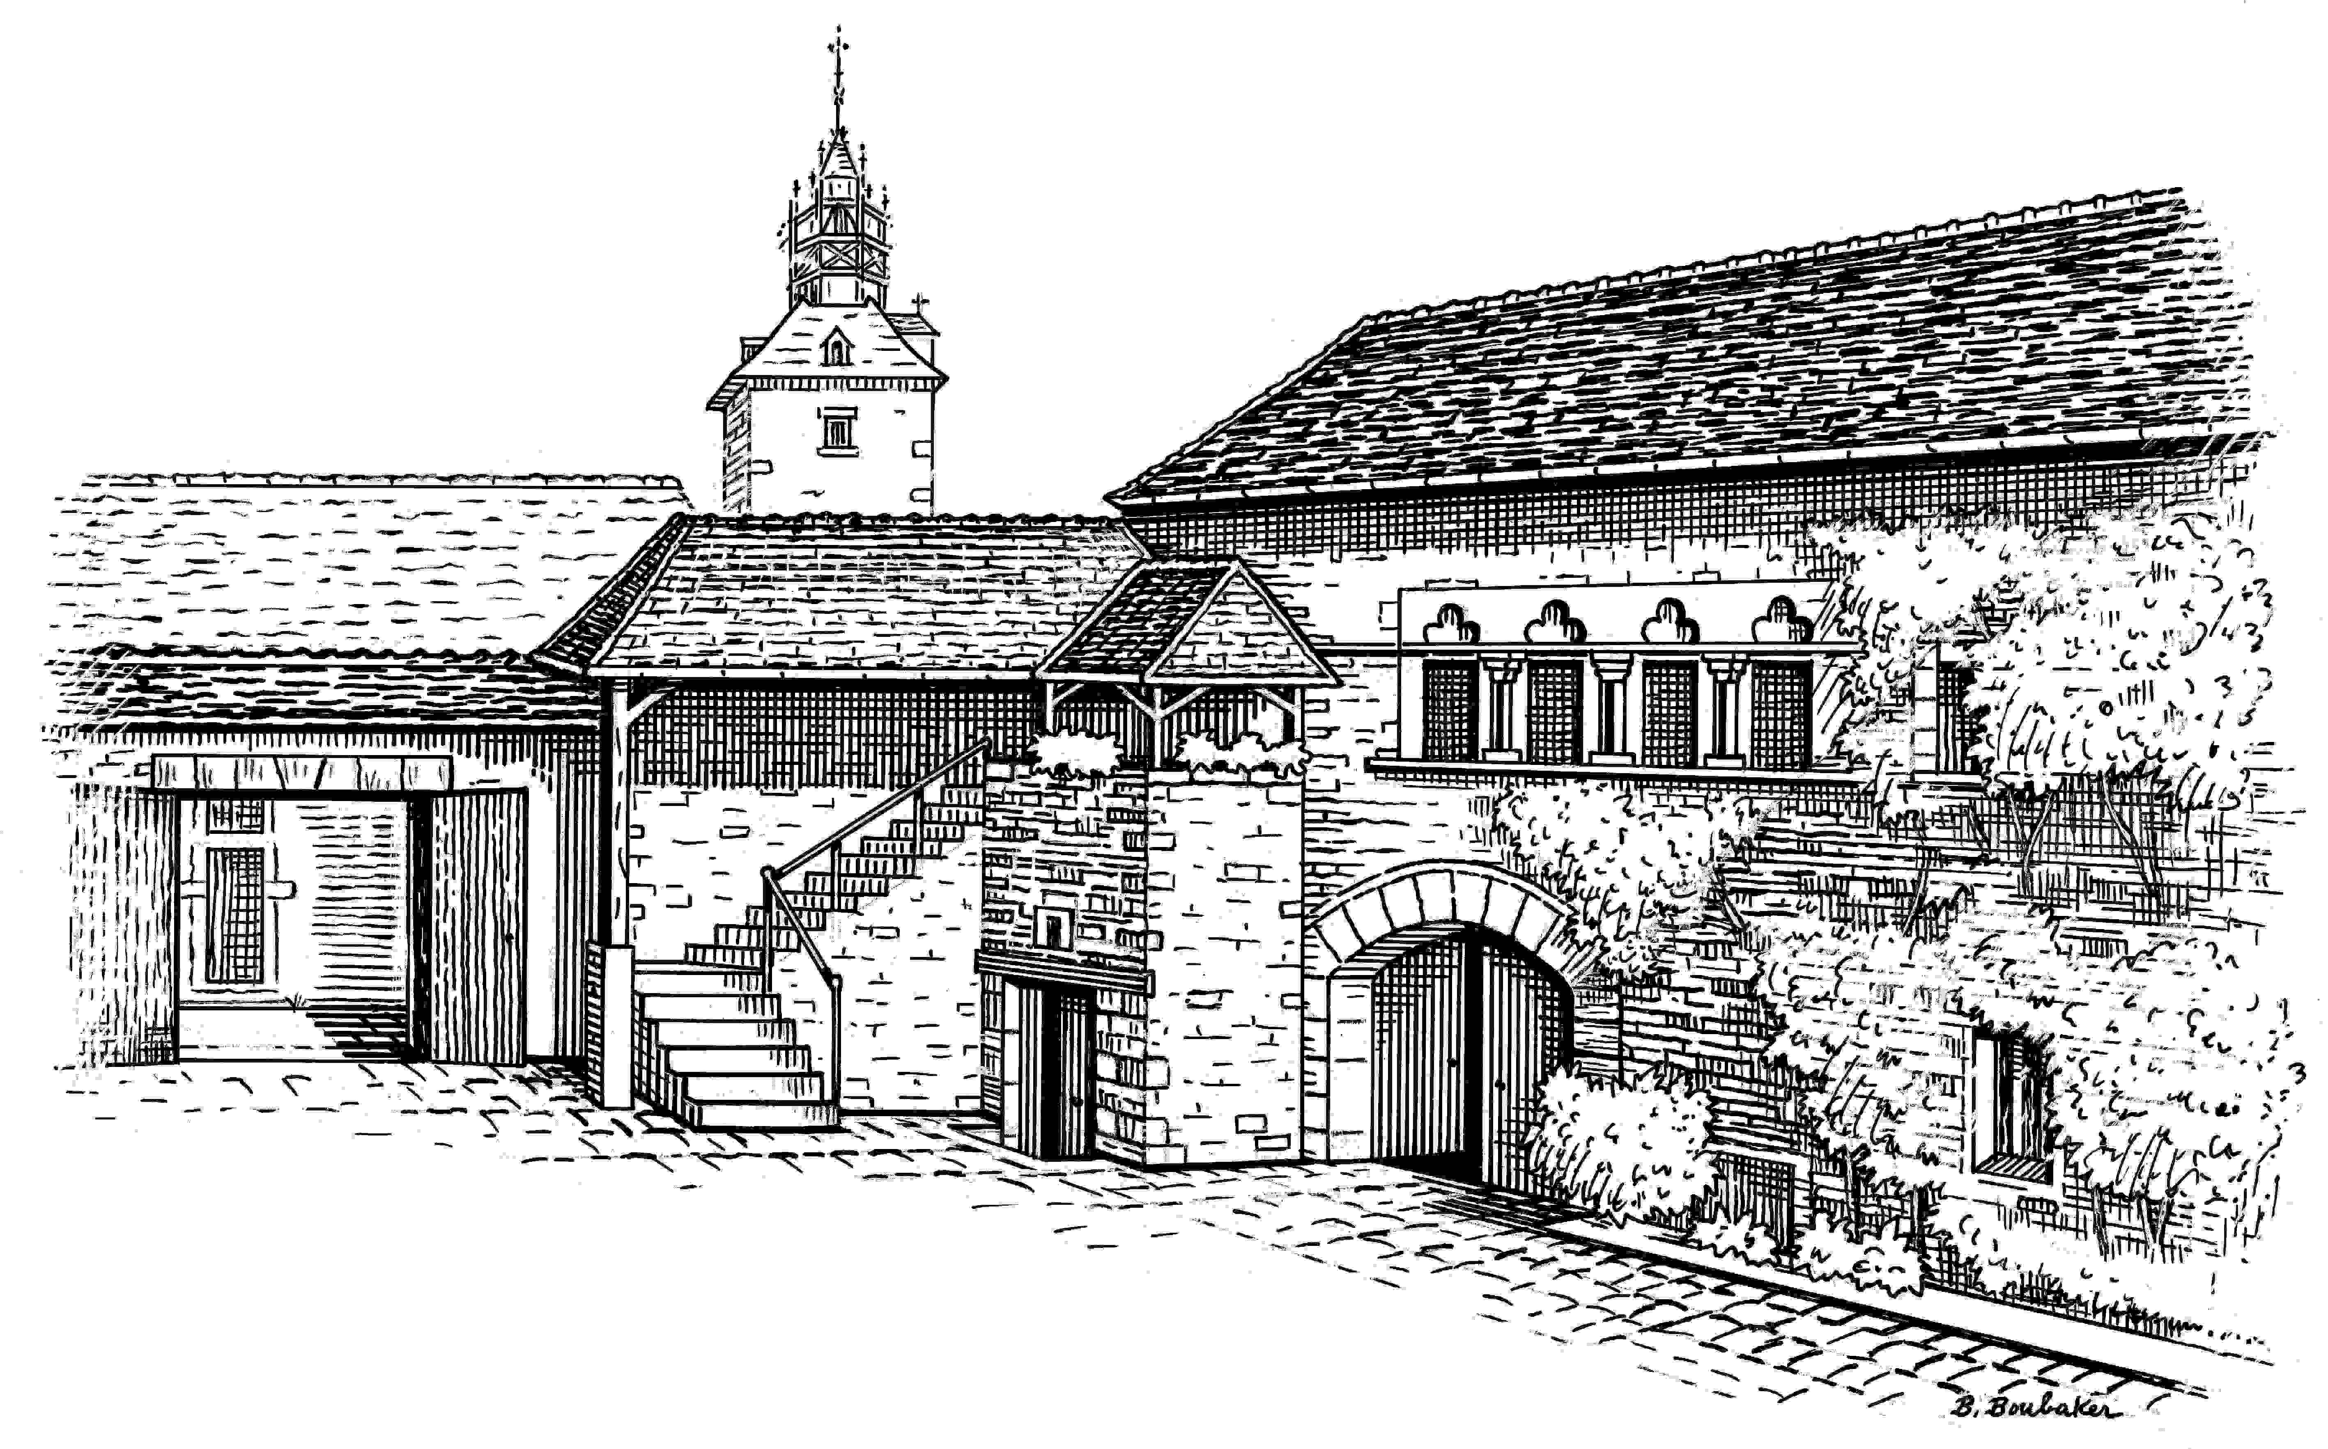
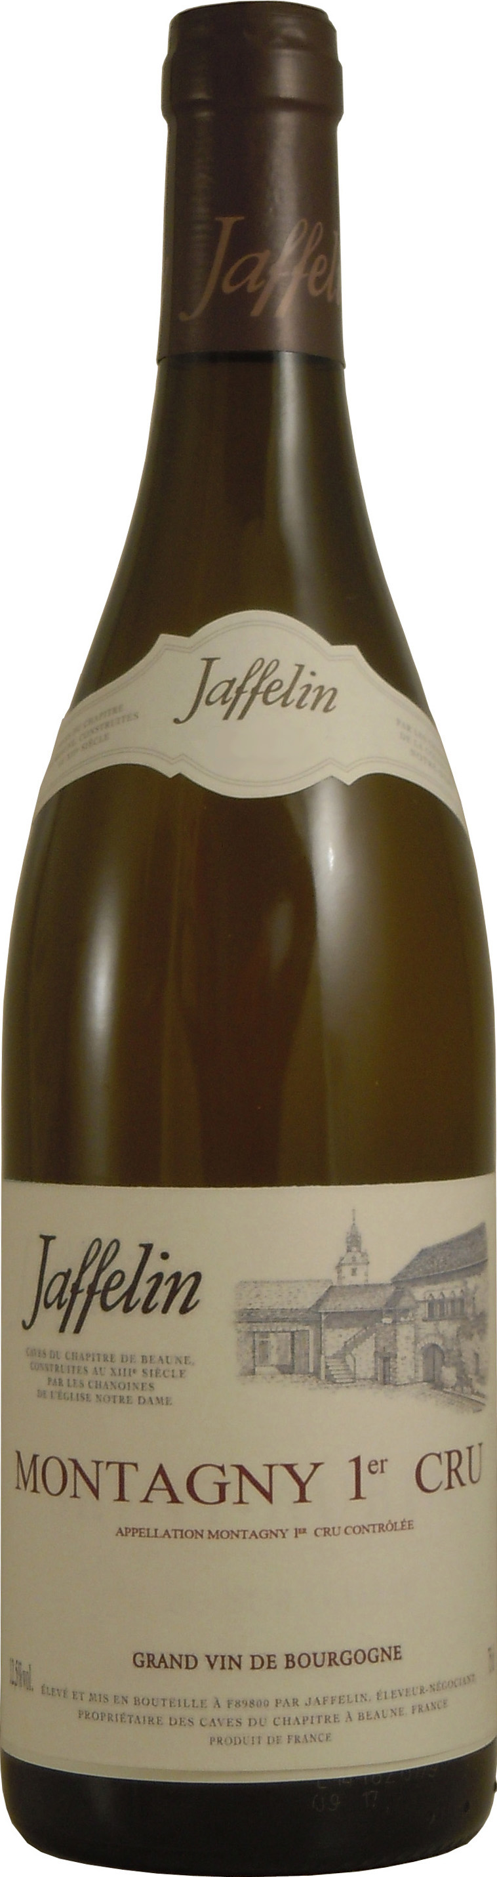

Montagny 1er Cru

DESCRIPTIVE & VINIFICATION

Grape variety: Chardonnay
Alcoholic fermentation takes place entirely in French oak barrels, of which 40% are new. The lees are stirred
(bâtonnage) occasionally during ageing, which lasts
11 months.

Located at the heart of the Côte Chalonnaise, the vineyards cover the slopes of 4 villages, including Montagny-lès-Buxy. This 301-ha appellation is entirely devoted to the cultivation of Chardonnay.
The vines are planted in calcareous clay soil.

TASTING NOTES

Colour: Lovely light yellow with straw-coloured highlights.
Nose: The first nose is vegetal with nuances of moss and white mushrooms, paving the way for a hint of oak, which is balanced and discrete.
Mouth: Soft tannins open up to notes of white blossoms. It shows good acidity and concentration.

ALLIANCE
Grilled fish, poultry, goat cheese
SERVICE TEMPERATURE
12°C / 14°C

AGEING POTENTIAL
Between 5 to 7 years

2 Rue Paradis – 21200 BEAUNE – Côte d’Or - France
Tél : 03 80 22 12 49 – Fax : 03 80 24 91 87 - Email : jaffelin@maisonjaffelin.com

